325 Education: UseR Guide for Zoom RoomS

How to Turn the displays on or off on the panel / ipad and start Zoom

- Press the iPad button to start it.
- Press the button again to log into the iPad
* No password required.

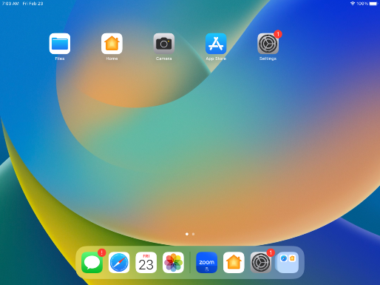

- Tap the Zoom icon to start the Zoom Rooms app.

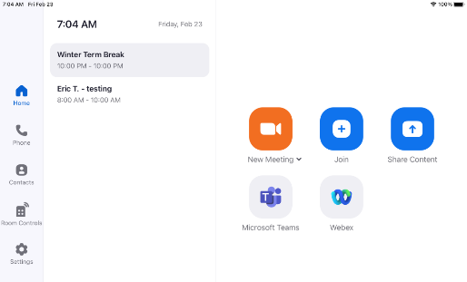

- Next, tap Room Controls at the left.

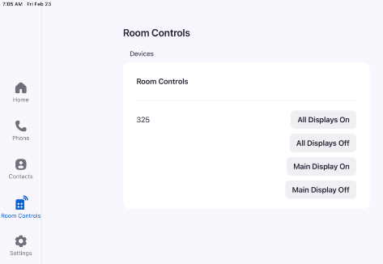

- Select the display to turn on or off.
- To turn on – tap Main Display On or All Displays On.
- To turn off – tap Main Display Off or All Displays Off.

Show instructor content on main display

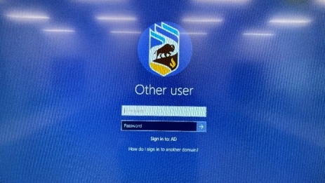
Using the local computer

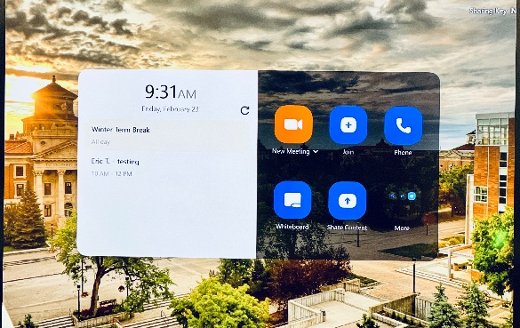
- On the main display, tap Share Content.

- The local computer is shown. Use the mouse and keyboard available in the room to log in with your accoun
Note: The local computer is connected to the wall panel USB ports, where you can insert USB drives.

Using your own laptop

- Connect it to the HDMI cable on the wall panel.
- From the main display, tap Share Content.
- Your personal laptop’s screen will be shown on the main display.

Stopping the share
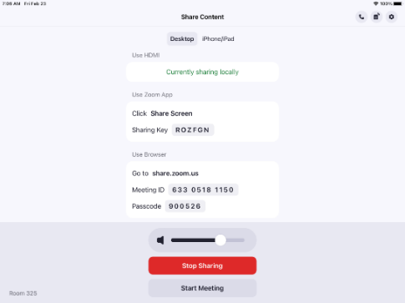
- Click Stop Sharing on the iPad.

Share from any device on the main display
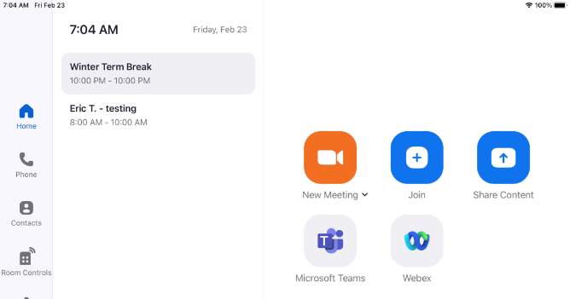
Both instructors and participants can share their content from their own devices on the main display.
- From the Zoom app on the iPad, tap Share Content.

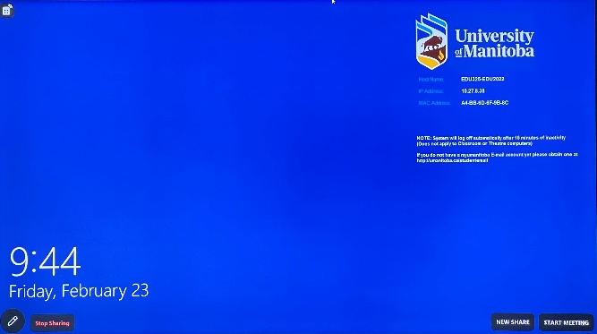

- On the main display, tap New Share.

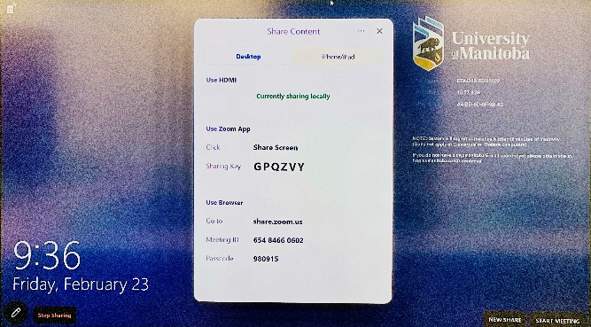

- The Share Content window opens on the main display. Take note of the Sharing Key.

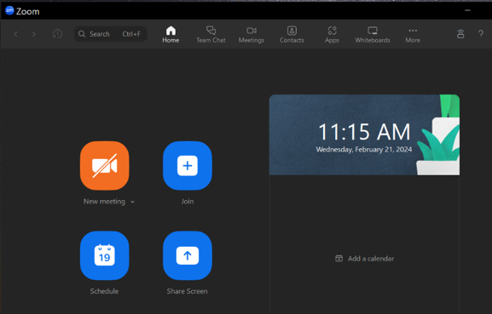

- From your own laptop, start the Zoom app (ensure that you are logged with your account into the Zoom app). Then, click Share Screen.

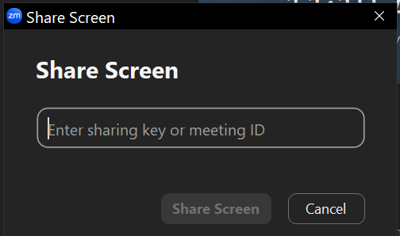
- Enter the Sharing Key (Step 3) from the main display and then click Share Screen.

Use videoconferencing with Zoom Rooms
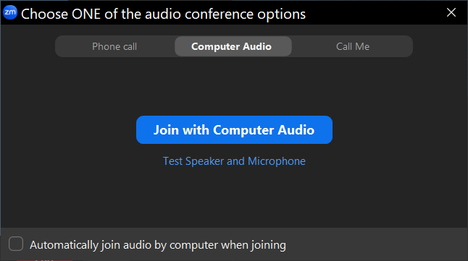
- Start the Zoom meeting from your laptop using Zoom app.
Note: Since you are in Room 325, ensure that you join the meeting without using the computer audio.
Click X to join without audio.

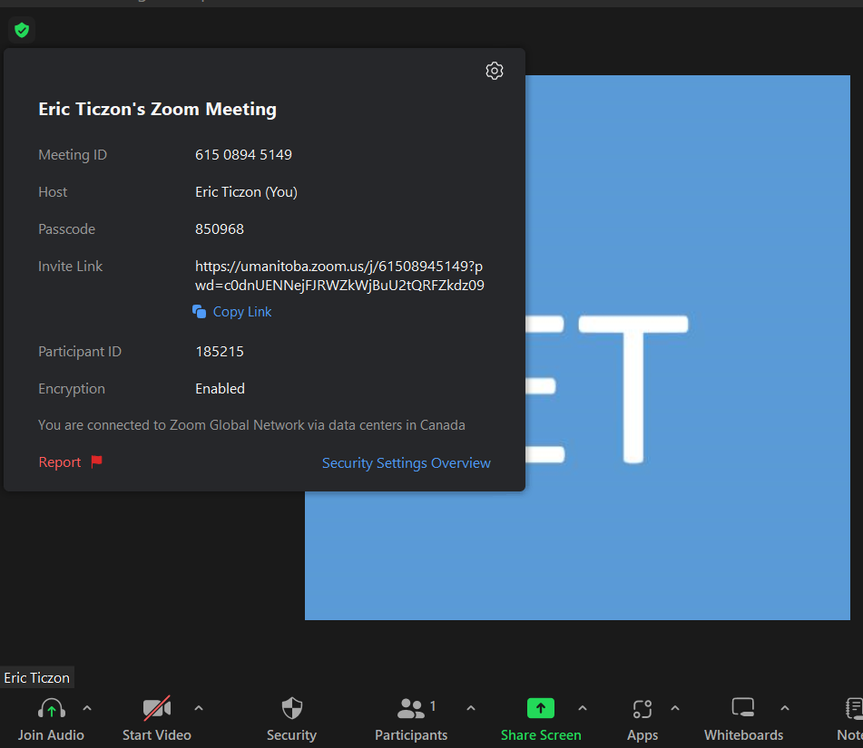
- From the upper left side of the Zoom meeting window on your laptop, click the meeting information icon to show the Meeting ID and Passcode.

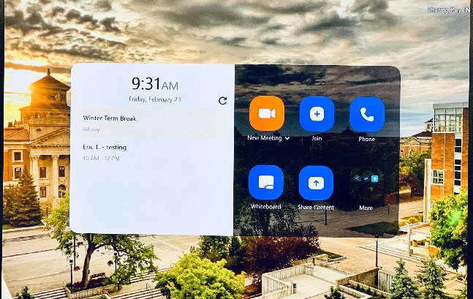
- From the main display, tap Join.

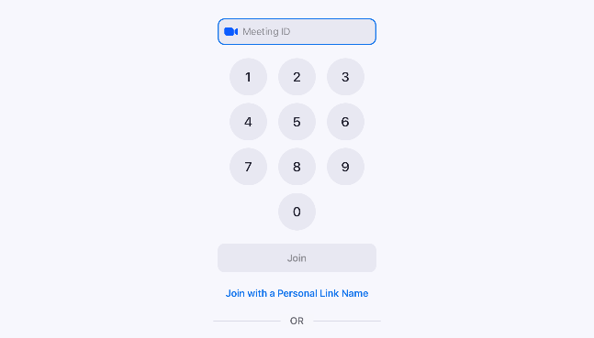
- Enter the Zoom Meeting ID and tap Join.

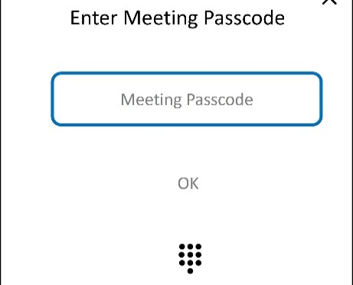
- On the next screen, enter the Zoom Meeting Passcode and then tap OK.

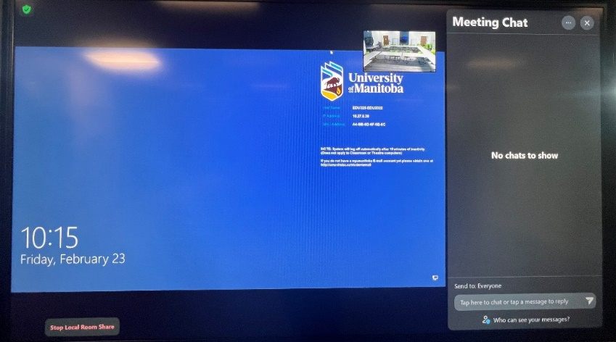
- The main display on Room 325 joins the Zoom meeting.

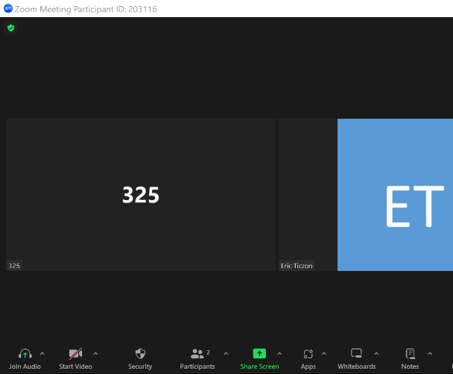
- To share content, click the Share button from the Zoom meeting on your laptop, since you are the host of the meeting.

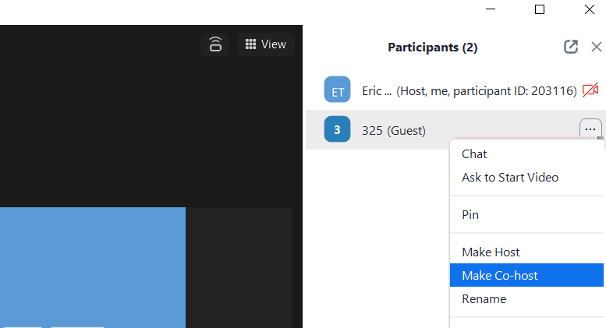
- If you want to add more participants using the main display, you need to make the Room 325 user a co-host.
- From the Zoom meeting on your laptop, click the more (…) button of the Room 325 participant and click Make Co-host.

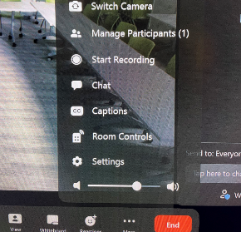
- Once Room 325 is a co-host, you can use the main display to add more participants by click the more (…) button> Manage Participants. You may need to admit new participants into the Zoom meeting by clicking Admit on the main display.
00000000
- Control camera and speaker volume from the iPad.
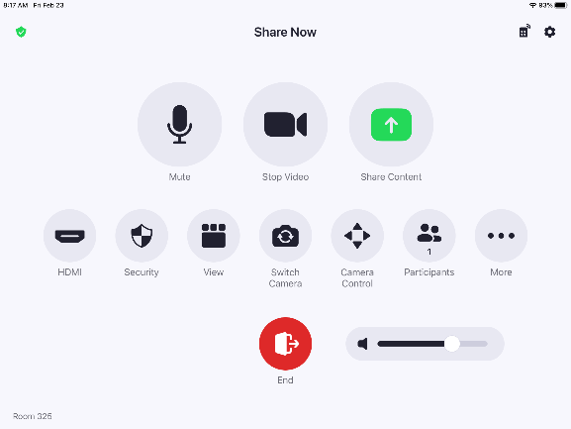
Camera position
Select the front or rear camera.
Speaker volume
- To end the Zoom meeting, click the End button from the Zoom app on your laptop.

leavE the room; Turn off main display or all displays
To turn off the main display or all displays in the room, from the iPad, tap Room Controls, and then tap Main Display Off or All Displays Off.

