COLLEGE OF REHABILITATION SCIENCES
DEPARTMENT OF PHYSICAL THERAPY
CLINICAL EDUCATION ACP EXPECTATIONS

When grading your students ACP, there are a few key documents to use for assisting in scoring. Look to the rating scale and anchor descriptors (p. 4 of the ACP) as well as the ACP Grading Resource rubric for assistance with the non-expert domains of the ACP. We have also put together a table below to guide you as to the U of M, MPT program’s expectations of where students should be for each of their placements. Concern about student performance arises when the average rank across all 18 questions of the ACP falls at or below the cutoffs listed below.
For any student whose average score is below the cutoffs identified, clinicians should reach out to the Academic Coordinator of Clinical Education as soon as possible. Students should also be made aware that they are not meeting expectations prior to the evaluations to allow for an opportunity to improve. Continuous feedback, student reflection and evening preparation as well as goal setting are integral for a successful placement.

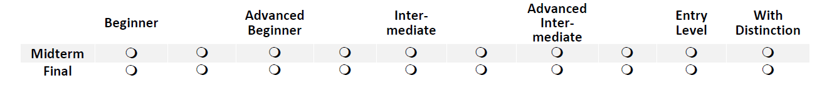
Cut off points for concerns about credit with reservation or no credit (failure) are as follows:
Placement | Final – achieves credit | Midterm Red Flags | Final – credit with reservation
1 – MPT 1 spring | Advanced beginner | Safety, behaviour, professionalism issues | Beginner
2 – MPT 2  Fall, slot 1 | Intermediate | Between beginner/Advanced Beginner | Advanced Beginner
3 – MPT 2 Fall, slot 2 | Between Intermediate/advanced intermediate | Advanced beginner | Between Adv. Beginner and Intermediate
4 – MPT 2, spring 1st placement | Advanced Intermediate | Between Advanced beginner/Intermediate | Intermediate
5 – MPT2, spring 2nd placement | Entry Level | Between Intermediate/advanced intermediate | Advanced intermediate

