Puffer: Cloud Formation
Thanks to Julia Matter

Description
This demonstration assists understanding the volatility of liquids, the properties of liquids and gases and chemical reactions. The following experiment demonstrates how an acid and a base can be used to make a smoke cloud. It may be used to introduce the physical properties of matter and acid-base neutralization reactions that form salts and properties of acids, bases and salts. Students can also enhance their understanding of a double displacement reaction while conducting this experiment. This demonstration is also valuable because it allows students to observe and explain the simple concepts of the volatility and diffusion that they have encounter in everyday life, but never really tried to understand how it works. This aspect may help students to connect classroom science to everyday life.

Curriculum

Senior 2: Cluster 2: Chemistry in Action
S2-2-07 Investigate and classify chemical reactions as synthesis, decomposition, single displacement, double displacement or combustion.
S2-2-08 Experiment to classify acids and bases using their characteristic properties.
S2-2-10 Explain how acids and bases interact to form a salt and water in the process of neutralization.

Chemistry 11: Unit 3: Chemical Reactions
C11-1-01 Describe the properties of gases, liquids, solids and plasma. Include: density, compressibility and diffusion.
C11-1-05 Use KMT to explain the processes of evaporation and condensation Include: intermolecular forces, random motion, volatility, dynamic equilibrium.
C11-3-05 Write and classify balanced chemical equations from written descriptions of reactants.
C11-3-06 Predict the products of chemical reactions given the reactants and type of reaction.

Materials
# of Materials Materials per experiment
1 | Long transparent glass tube with end caps & cotton balls
2 | 10 ml graduated cylinders
2 | Large test tubes
4 | L-shaped glass tubes
3 | 2-hole rubber stoppers
1 | T-tube
2 | Rubber tubing
1 | Test tube rack
2 | Cotton Balls
1 | Large round glass tube with caps
 | 10 ml concentrated HCL
 | 10 ml ammonium hydroxide( solution of ammonia)

Safety Considerations and Cautions
- It is important for students to get a first-hand experience with these liquids. But because they are volatile and cause skin and eye irritations they must be dealt with carefully.
- Both of the chemicals, the hydrochloric acid and ammonium hydroxide, must be handled with care and not ingested in any way. Caution: Causes eye and skin burns. Causes digestive and respiratory tract burns.
- Both of the chemicals give off a strong odour so this experiment should be conducted in the fume hood. Do not deeply inhale the fumes.
- Safety goggles and gloves must be worn to conduct this experiment.
- If you get either substance on your skin or eyes, wash the exposed area well with lots of water of at least 15 minutes. Get medical aid immediately.
- Handle all glass objects with care. If any break, clean up the glass pieces with a dust pan and broom and dispose them in a glass disposable unit.
- Any waste materials can be poured down the sink with lots of water.

Presentation Procedures & Extensions
There are various ways of performing this demonstration

Initial Step:

If you think it is appropriate open stock bottles of these two chemicals in front of the class (ensure a safe distance) ensuring the bottles are at least a metre apart.

In time, students may smell the ammonia. Comment on its volatility.

In time, move the bottles closer together. Note any reaction and where the reaction is occurring. It is likely that the smoke cloud that forms will form nearer one bottle than the otherl. Don’t discuss reasons or what is happening at length. Just that they are “meeting”.

Move the demonstration to either one of the procedures outlined below or both if you should so decide. The second (Part 2) is suggested drawing from some of the detail of explanation in Part 1.

Part 1: Test Tube Apparatus

This is more complex and doesn’t show some important subtle aspects of diffusion:

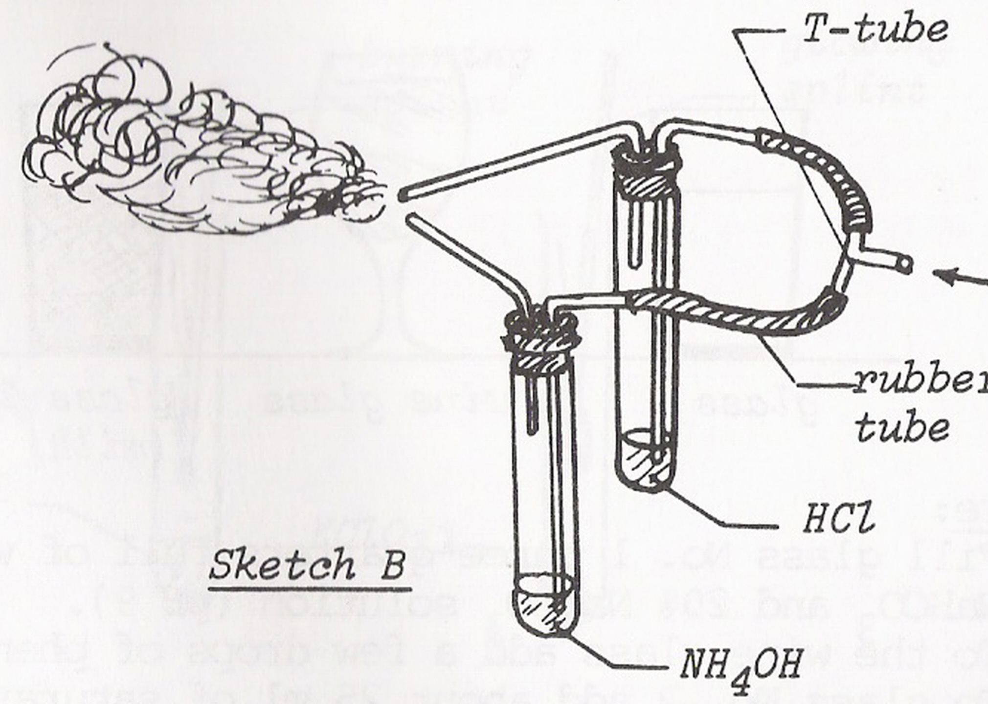

  - Insert 2 L-tubes into a 2-hole rubber stopper. Repeat this with the other stopper.
  - Attach 2 rubber tubes to two of the adjacent ends of a T-tube.
  - Attach the other end of each rubber tube to one L-tube on each of the rubber stoppers. This will make a loop from one stopper to the other.
  - Place 2 large test tubes into a test tube rack and place the two rubber stoppers on top of them.

Ask the students if they can identify the liquids that will be used for the demonstration.
They should be able to identify them as clear liquids; however they may not be able to identify them specifically as hydrochloric acid and ammonia hydroxide.

What are some characteristics or properties of these two chemicals?
They will probably realize that the hydrochloric acid is an acid that gives off a strong smell because it is volatile; chlorine is a bleaching agent and it is likely some students have heard of hydrochloric acid produced in the stomach to assist in breaking down foods. They will probably realize that the ammonia hydroxide is a base from the word hydroxide. They may have heard of ammonia in ammonia-containing household cleaners (window cleaners) or smelling salts that also gives off a strong odour.

- Ask the students to identify some characteristics (taste, colour change and pH) of acids and bases.
They may know that:
Acids are sour tasting, corrosive substances and that they turn blue litmus paper red.
Bases are bitter tasting and turn red litmus paper blue.

Most students will know that:
Acids have low pHs
Bases have high pHs

- Teacher can use litmus paper to test the fumes coming from each liquid to identify where it is an acid or a base.
Teacher will explain that acids turn blue litmus paper to red and that bases turn red litmus paper to blue.

- Now, show students the apparatus - two different test tubes and place the rubber stoppers back on top of each test tube.
Students may suggest that:
-there will be an explosion
-there will be a reaction
-there will be a colour change
-nothing will happen (This is the correct answer)

- Measure 10 ml of HCL into a graduated cylinder and then pour it into one of the test tubes. Measure 10 ml of NH4OH ( a solution of ammonia in which the ammonia rapidly escapes) into another graduated cylinder and then pour it into the second test tube. Place the rubber stoppers back onto the test tubes.

- Now, ask the students to predict what they think will happen when air is blown into the open end of the T-tube.
Students may say the same things again as listed in step 5.
- Pick a student to blow through the T-tube forcefully, making sure that the two open ends to the L-tubes are close together.
Students will not be expecting a cloud of smoke to be formed at the end of the two L-tubes because the liquids are not physically mixing together.

- Pick another student to blow through the T-tube forcefully, making sure that the two open ends to the L-tubes are NOT close together. Ask students to predict what they think will happen again.
Some students may expect another cloud of smoke to form, while others will realize that nothing will happen because the two substances are not allowed to interact.

- Ask the students to try and explain what happened.
Students may understand that somehow the two chemicals must have interacted at the opening of the tube which created a cloud of smoke.
Explain that the gas vapors of both liquids in the test tubes were forced up out of the test tube by the rapidly moving air blown into the T-tube. The two gaseous vapor particles collided at the opening of the L-tube, causing the bonds to break and reform to create a salt.
A smoke cloud was made from the small salt particles suspended in the air. Smoke is simply a suspension of tiny solid particles in a gas.

  - What are the products of the reaction?
  - What are the reactants of the reaction?
  - Write a complete chemical reaction to determine what the products are from the reaction of an acid, HCL (g) and a base, NH3 (g). Help students to realize the ammonium hydroxide is a solution of ammonia in water and the ammonia rapidly escapes because it is so volatile. Make sure to include the physical state of the substances.

HCl (g) + NH3 (g) ----------> NH4Cl (s)
acid base salt

Explain to students that the NH4Cl is a solid and it is a salt.
Explain that many acid base reactions make salts.

g) What are some properties or characteristics of salts?

-Salts can form ionic compounds. For example: NH4Cl --- > NH4+ and Cl-
-Salts are good conductors of electricity.

Using the particulate explanation and models provided below, explain to students that acids neutralize bases in an acid-base neutralization reaction. An acid and a base combine to make a salt and water. A salt is any ionic compound that could be made with the anion (negatively charged ion) of an acid and the cation (positively charged ion) of a base. The hydrogen ion of the acid and the hydroxide ion of the base unite to form water.
Explain that this is also a synthesis reaction because a new compound is made from two original compounds. What are some examples of objects or activities that use smoke in the real world?
-sky writers
-smoke detectors

Smoke, used for sky-writing by planes, is produced by spraying special oils and paraffins on the hot exhaust of the airplane.
Smoke detectors use a specific substance (Americium 241 isotope) to detect smoke from a fire and then trigger the alarm. The smoke acts to interrupt the flow of electricity through the device, which acts to set of the alarm.

Part 2: Glass Tube Apparatus

This is a much easier process:

- Dip a cotton ball in the liquid HCl and attach it to the inside of the cap of the large glass tube. Dip another cotton ball in NH4OH and attach it to the inside of the cap on the other side of the glass tube.
- Ask the students to predict what they think will happen as they attach the two caps to the glass tube.
Most students will say that another cloud will be formed.

Ask the students where in the glass they think the cloud will be formed?
Most students will probably think it will appear in the middle but may draw from their initial experience with the stock bottles.
Some will say the cloud will form near the HCL because it is a very strong acid.
Some will say in near the NH4OH because it is stronger than the acid.

- Now, close the glass tube with the caps and observe what happens.
The cloud should form nearer the ammonium hydroxide. Get students to suggest why. Get them to consider the actual nature of the molecules reacting. Explain to students that the cloud was created on the side nearest the HCl because it has a greater molecular weight than the NH3.

Explain that the NH3 gaseous vapor particles diffuse or travel through the air a lot quicker than the HCl because they are lighter in weight. Thus the cloud will be created closer to the NH3 cotton ball, not in the middle of the glass tube. At both ends molecular collisions force the diffusion of reactants from areas of high to low concentrations.

- Remove the caps from the glass tube and observe what happens.
The cloud of smoke that has collected in the tube will rise up out of both ends of the tube.

- Ask the students why they think the cloud of smoke rose up into the air. Why did it not go downwards?
The students may say the cloud of smoke is lighter than the air.

Three levels of Representation

- Macroscopic level
Five Senses:
Both chemicals, HCl and NH4OH, are clear liquids and volatile. They move from the liquid phase to the vapour phase easily. In the case of the NH4OH it releases molecular NH3. They both have a very strong pungent odour that makes your nose burn and eyes irritated. The concentrated HCl releases a white cloud of smoke immediately upon being released into the air. When you blow into the apparatus, a white cloud is formed at the opening of the two L-tubes. The cloud is only formed when the L-tube are close to one another. In the glass tube, the cloud is created closer to the end with the HCl. When the glass tube is opened, the smoke that has collected in the tube escapes from both ends and rises up into the air.

- Particulate level
Both liquids are volatile easily and diffuse easily. As the particles collide they diffuse outward from the more concentrated area in which they are located. Because they have different molecular masses, they diffuse at different rates. When they interact and collide a chemical reaction (which is very easy to role play) results. Get 4 students to represent NH3 and 2 to represent HCL. Enact a role play showing collision, bound breaking and reforming to produce NH4Cl.

The smoke cloud is created from the solid salt, NH4CL, particles dispersed amongst the air and water vapor, H20. Smoke is often made when two substances are suspended in the air, in which one substance is in a solid phase and the other is in a gas phase. Thus, the smoke cloud becomes visible to the naked eye.

- Symbolic level

Combining of the Hydrochloric acid and Ammonia by the Air

HCl (l) + NH3 (g) ---> NH4Cl (s)

In this interaction, the hydrochloric acid and ammonium hydroxide are both changing the states, from liquid to gas. This allows the air to push these gases out of the test tube and out of the L-tube.

Interaction between the Hydrochloric Acid and the Ammonia

HCl(g) + NH3(g) --------> NH4Cl(s)
Acid Base Salt

In this interaction, the hydrochloric acid and ammonia combine to form to a salt and water.
The smoke screen is made from the solid salt particles suspended in the air in the water vapor.

References

Liem, T. 1987 Make a Smoke Screen. In Invitations to Science Inquiry 2nd Ed. Science Inquiry Enterprises. Chino Hills, CA Pp. 144
Rayner-Canham, G. and Last, A. 1988 Chemistry: A Last Course. Addison-Wesley Publishers. Don Mills, Ont. Pp. 198-246, and 348-383.

