How to Get Started using WebEx

How to Get Started using WebEx
Access to Cisco WebEx requires an account. To request one, please contact the IST Service Desk:
Information Services and Technology
123 Fletcher Argue
University of Manitoba, Winnipeg, MB R3T 2N2 Canada
Office: 204-474-8600 Servicedesk@umanitoba.ca
First Time Login
When your account is created, you will receive an email from Cisco with the subject “University of Manitoba has invited you to Cisco Webex.”
Follow the email instructions if this is your first time logging into Cisco WebEx:
- Locate the Cisco WebEx invitation email.
- Select “Activate.”
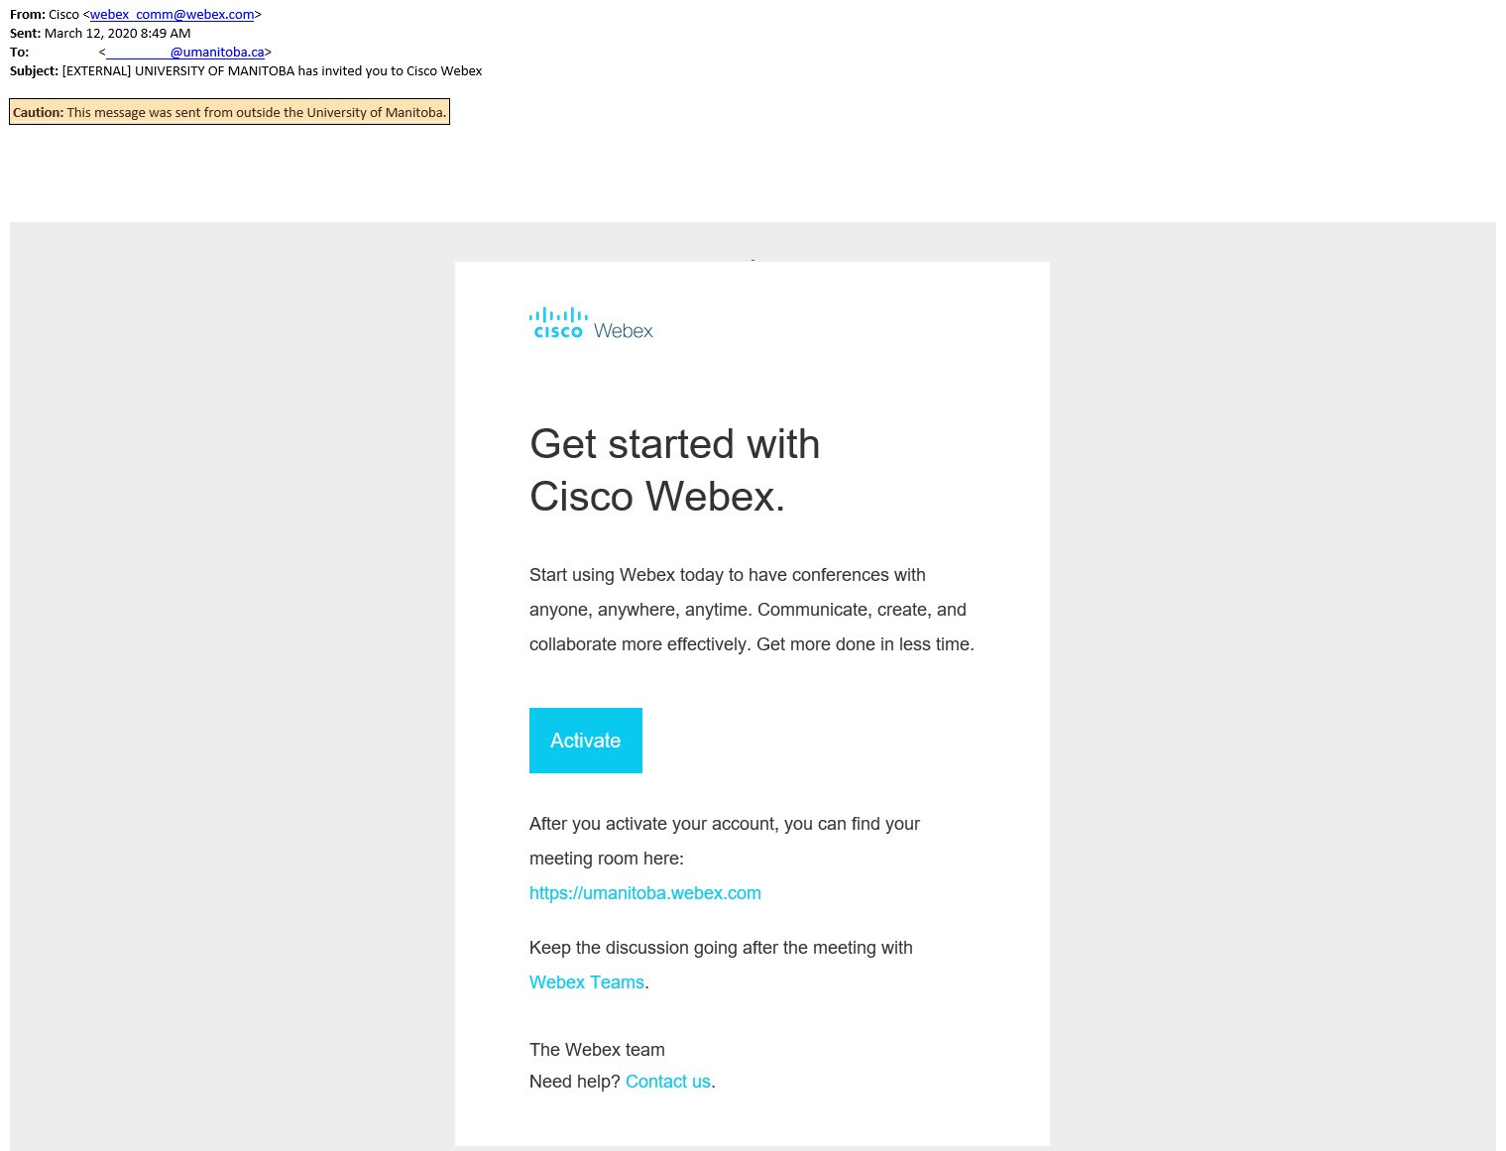

- Create a new password. 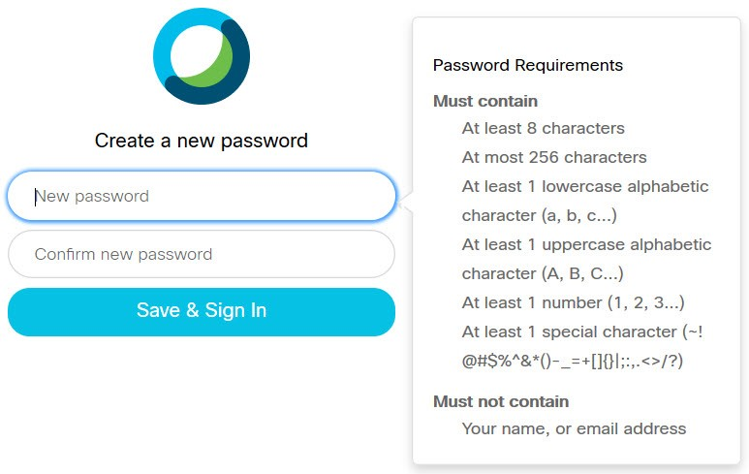
- Once you have your password created, the following webpage will open. https://umanitoba.webex.com/
- Click “Sign In” to enter your meeting room.
- Once signed in, you can start or schedule a meeting using the web app. 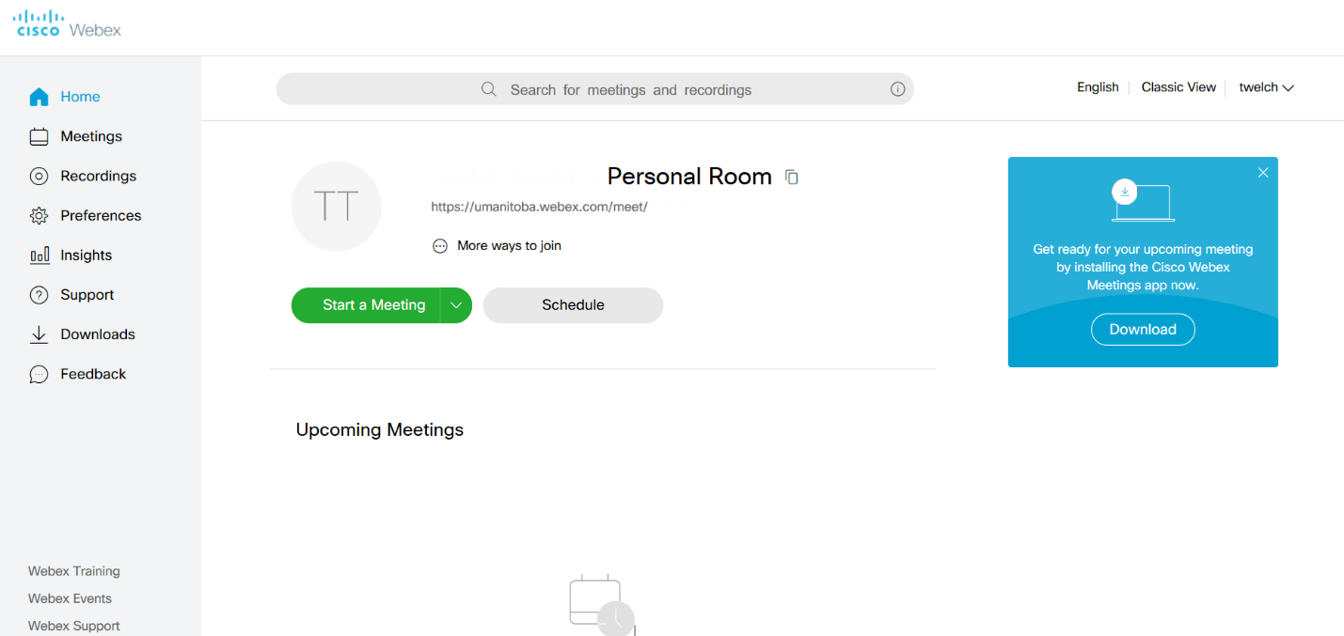

Start A Meeting Using the Web App

Click on
When starting up a meeting for the first time, you will be prompted to allow the site access to your camera and microphone.
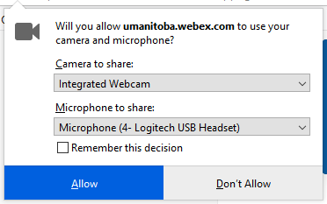
You can select “Remember this decision” and then click “Allow.”
A preview window will open that will allow you to enable and disable your camera and audio before starting the meeting.
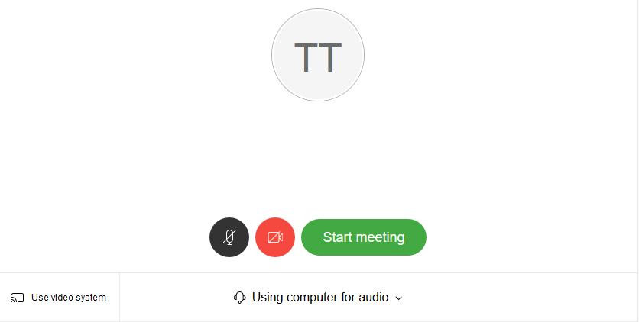
Click “Start meeting,” and your browser will open the meeting room.
Once in your meeting room, a control panel will be at the bottom of the page, allowing you to access the different functions and features.

Adding/Inviting Participants

You will need either your meeting room link or meeting number to invite participants to your meeting. The information is available by clicking the “i” in the upper left corner of the meeting window.
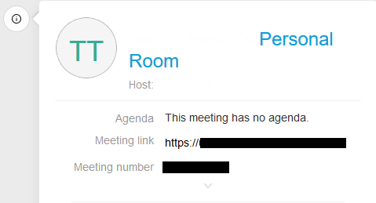
To end the meeting, click the red X and select “End Meeting.”
